Chapter 15, Problem 52.

Use the Laplace transform to find i(t) for t > 0 if

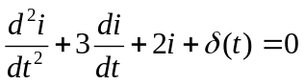,

i(0) = 0, i'(0) = 3

